Bulls

and cows

python

project

Сделал ученик 7 класса Крестинин Лука, школы “Летово”, группы 7.1.

Москва 16.12.2020

Содержание (ссылки кликаются):

Основное правило игры: 2

Функционал: 2

Miro map: 3

Скриншоты: 4

Код: 7

# Основное правило игры:

Компьютер задумывает четыре различные цифры из 0,1, 2...9. Игрок делает ходы, чтобы узнать эти цифры и их порядок.

Каждый ход состоит из четырёх цифр, 0 может стоять на первом месте.

В ответ компьютер показывает число отгаданных цифр, стоящих на своих местах (число быков) и число отгаданных цифр, стоящих не на своих местах (число коров).

# Функционал:

При входе в игру вас просят зарегистрироваться, хотя это одноразовый логин. Далее вам выводят сообщение по типу добро пожаловать. Далее вы можете написать эти команды: rules, account, shop, play (, hack). Сейчас разберем каждую из команд.

Rules) Эта команда просто выводит правила игры

Account) Эта команда показывает: кол-во побед, кол-во проигрышей, ваш логин, ваш никнейм с вашим цветом и кол-во очков (валюты)

Shop) Эта команда вызовет магазин. В магазине вы можете купить 1) цвет всего текста, 2) цвет вашего никнейма и 3) секрет.

1. Вам дадут выбор из 6 цветов:

1)BLUE, 500

2) CYAN, 1000

3) GREEN, 2000

4) MAGENTA, 5000

5) RED, 10000

6) YELLOW, 20000

После выбора при условии, что вам хватает очков, вы получите товар.

1. Вам также дадут выбор из 6 цветов:

1) BLUE, 1000

2) CYAN, 2000

3) GREEN, 4000

4) MAGENTA, 10000

5) RED, 20000

6) YELLOW, 40000

После выбора при условии, что вам хватает очков, вы получите товар.

1. Вам напишут 3 раза уверены ли вы, если на все три раза вы ответите “yes”, то у вас активируется “секрет”, весь текст будет с эффектом “Glitch” (Это можно отключить, так как после покупки этот товар меняется и на нем написано отключить секрет. Отключение секрета тоже за очки)

Play) После этой команды вам нужно будет выбрать играть онлайн или офлайн. Если вкратце, то офлайн это обычная игра с ботом, в которой есть проверка на 4-значное число (после ошибки поясняется, что именно не так), также при этой игре не дают награды. Онлайн это фактически та же игра с ботом, но с симуляцией онлайна (время ожидания, рандомный никнейм из 11000 вариантов с рандомным цветом, время размышления, таймаут, противник угадывает за 10-30 попыток). Также после этой игры начисляются баллы (формула баллов: (ваши попытки - попытки противника) * 500).

Hack) Вам дают +10000 побед и +100000000000 очков (для разработчиков)

# Miro map:

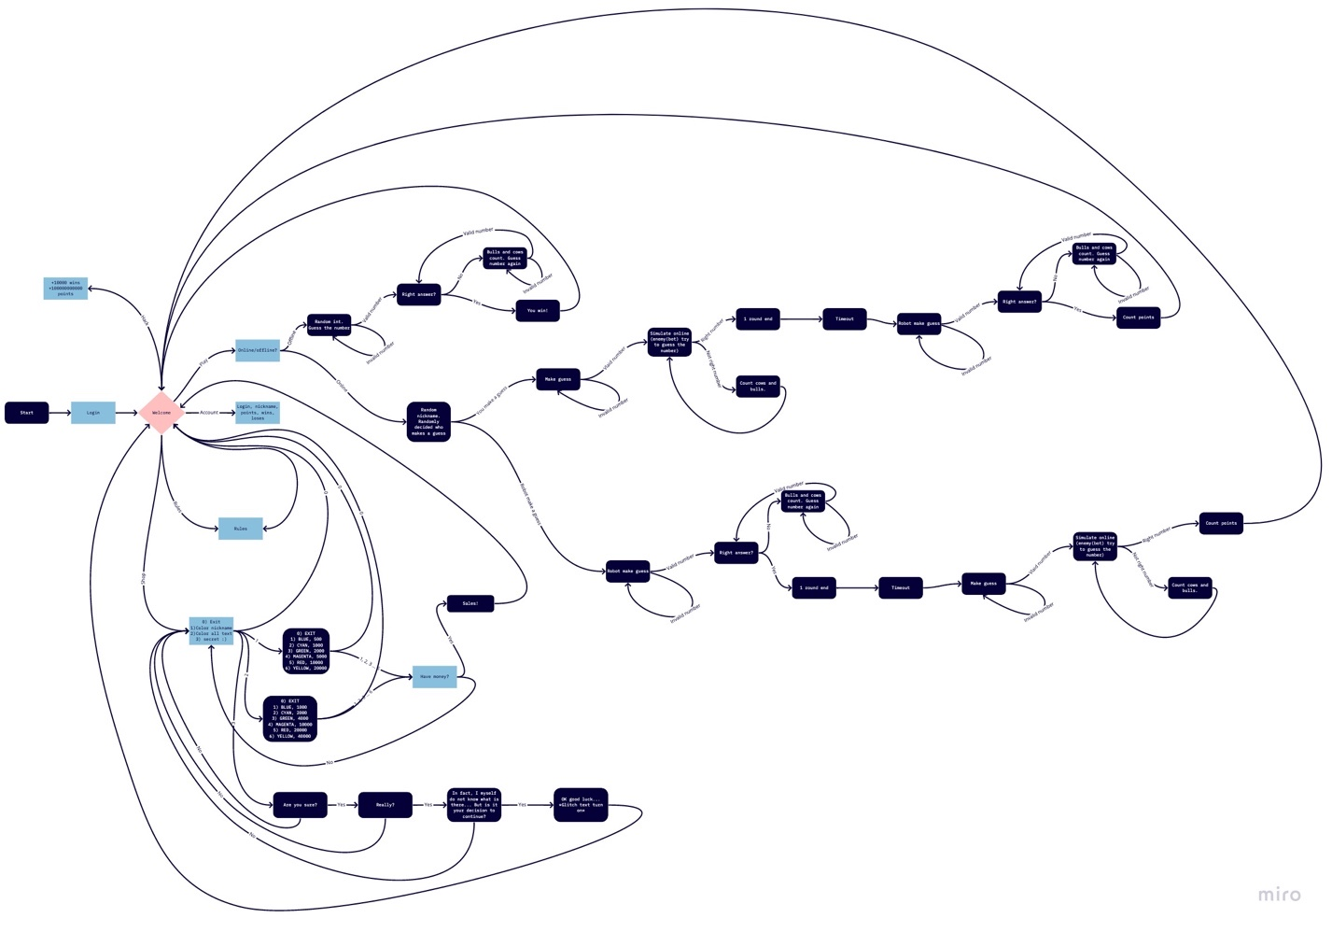

<https://miro.com/app/board/o9J_lbZkVoA=/>

# Скриншоты:

Правила:

Игра офлайн: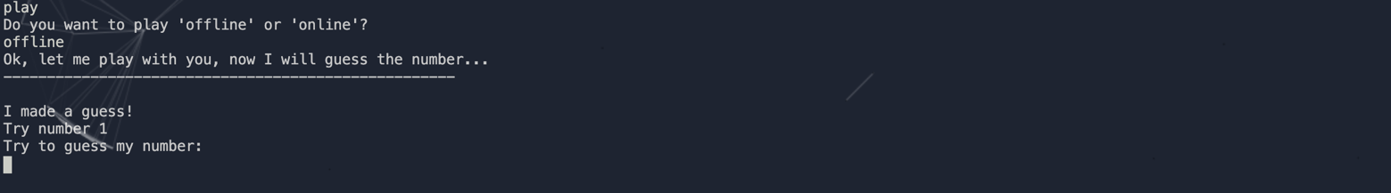

Игра онлайн: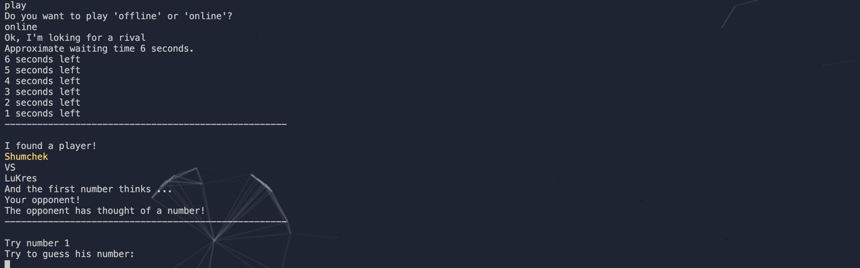

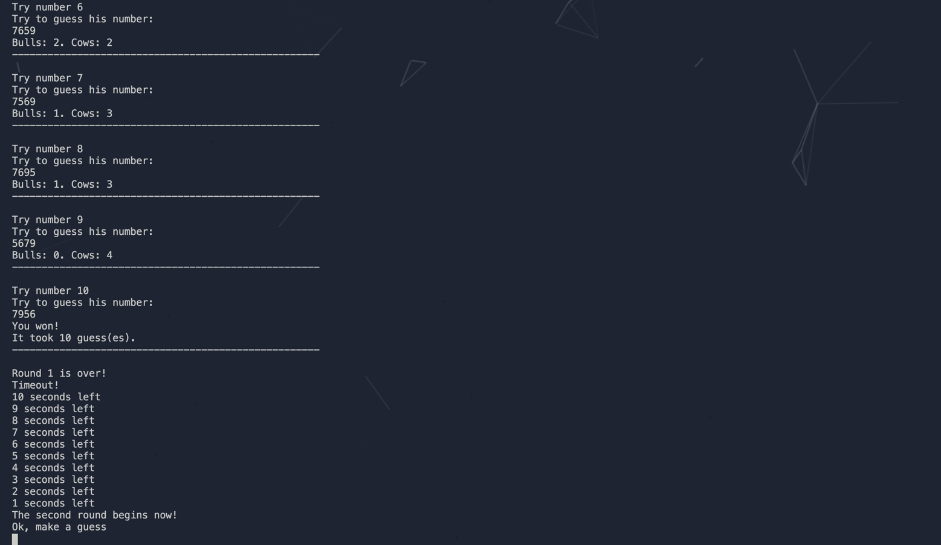

Аккаунт:

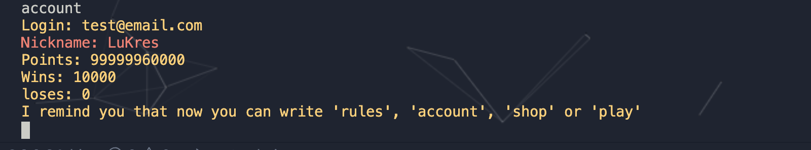

Магазин: 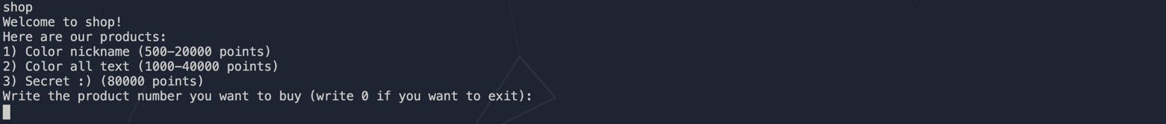

Hack:



# Код:

import random *#random*

import time *#use for time.sleep()*

from termcolor import colored *# color text*

from zalgo_text import zalgo *# glitch text :))*

import os

THIS_FOLDER = os.path.dirname(os.path.abspath(__file__))

my_file = os.path.join(THIS_FOLDER, 'BoyUsers.txt')

lines = open(my_file).read().splitlines() *#random nicknames*

def DurakCheckFunction(guess): *#check for invalid numbers*

DurakCheck=0

key=[1,2,3,4,5,6,7,8,9,0]

if len(guess)!=4:

DurakCheck=1

elif guess[0] not in key: *#check for digits*

DurakCheck=2

elif guess[1] not in key:

DurakCheck=2

elif guess[2] not in key:

DurakCheck=2

elif guess[3] not in key:

DurakCheck=2

else:

q=guess.count(1) *#check for wtimes or more digits*

w=guess.count(2)

e=guess.count(3)

r=guess.count(4)

t=guess.count(5)

y=guess.count(6)

u=guess.count(7)

i=guess.count(8)

o=guess.count(9)

p=guess.count(0)

if q>1 or w>1 or e>1 or r>1 or t>1 or y>1 or u>1 or i>1 or o>1 or p>1:

DurakCheck=3

return(DurakCheck)

def GameOnlineOpponent(): *#play with opponent (opponent (bot :)) make guess)*

number = random.sample(range(10), 4)

*#printAt(f'Solution: {*number,}'), for develop*

time.sleep(2)

printAt('The opponent has thought of a number!')

printAt("---------------------------------------------------- \n")

tryes=0

while True:

tryes+=1

printAt(f'Try number {tryes}')

printAt("Try to guess his number:")

try:

guess = [int(i) for i in input()]

if DurakCheckFunction(guess) == 0:

if guess == number: *#win check*

printAt("You won!")

printAt(f"It took {tryes} guess(es).")

printAt("---------------------------------------------------- \n")

return(tryes)

else: *#how many bulls and cows*

cow=0

bull=0

for i in range(4):

if guess[i]==number[i]:

bull += 1

elif guess[i] in number:

cow += 1

printAt(f"Bulls: {bull}. Cows: {cow}")

printAt("---------------------------------------------------- \n")

elif DurakCheckFunction(guess) == 1: *#errors*

printAt('The guess must be 4-digit')

printAt("---------------------------------------------------- \n")

elif DurakCheckFunction(guess) == 2:

printAt('The guess must be only digits')

printAt("---------------------------------------------------- \n")

elif DurakCheckFunction(guess) == 3:

printAt('The guess must be composed of different digits')

printAt("---------------------------------------------------- \n")

except:

printAt('The guess must be only digits')

printAt("---------------------------------------------------- \n")

def GameOnlineYou(): *#play with opponent (you make guess)*

printAt('Ok, make a guess')

while True:

number=[int(i) for i in input()]

if DurakCheckFunction(number) == 1: *#errors*

printAt('The guess must be 4-digit')

printAt("---------------------------------------------------- \n")

printAt('Guess the number one more time')

elif DurakCheckFunction(number) == 2:

printAt('The guess must be only digits')

printAt("---------------------------------------------------- \n")

printAt('Guess the number one more time')

elif DurakCheckFunction(number) == 3:

printAt('The guess must be composed of different digits')

printAt("---------------------------------------------------- \n")

printAt('Guess the number one more time')

else:

break

printAt("---------------------------------------------------- \n")

number = random.sample(range(10), 4)

printAt('The opponent starts to guess the number!')

tryes=0

for i in range (random.randint(7,30)):

tryes+=1

printAt(f"Try number {tryes}")

printAt("The enemy is trying to guess the number ...")

time.sleep(random.randint(1,3)) *#random output to simulate online*

guess = random.sample(range(10), 4)

''.join(map(str, guess))

printAt(f'{*guess,}')

cow=0

bull=0

for i in range(4):

if guess[i]==number[i]:

bull += 1

elif guess[i] in number:

cow += 1

printAt(f"Bulls: {bull}. Cows: {cow}")

printAt("---------------------------------------------------- \n")

tryes+=1

time.sleep(random.randint(1,3)) *#right number from computer*

printAt(f"Try number {tryes}")

printAt("The enemy is trying to guess the number ...")

printAt(f'{*number,}')

printAt("The enemy has guessed right!")

printAt(f"It took him {tryes} guess(es).")

printAt("---------------------------------------------------- \n")

return(tryes)

def GameOffline(): *#play offline (bot make guess)*

printAt('Ok, let me play with you, now I will guess the number...')

time.sleep(3)

printAt("---------------------------------------------------- \n")

number = random.sample(range(10), 4)

printAt('I made a guess!')

*#printAt(f'Solution: {*number,}'), for develop*

tryes=0

while True:

tryes+=1

printAt(f"Try number {tryes}")

printAt("Try to guess my number:")

try:

guess = [int(i) for i in input()]

if DurakCheckFunction(guess) == 0:

if guess == number:

printAt("You won!") *#win check*

printAt(f"It took {tryes} guess(es).")

printAt("---------------------------------------------------- \n")

return(tryes)

else: *#how many bulls and cows*

cow=0

bull=0

for i in range(4):

if guess[i]==number[i]:

bull += 1

elif guess[i] in number:

cow += 1

printAt(f"Bulls: {bull}. Cows: {cow}")

printAt("---------------------------------------------------- \n")

elif DurakCheckFunction(guess) == 1: *#errors*

printAt('The guess must be 4-digit')

printAt("---------------------------------------------------- \n")

elif DurakCheckFunction(guess) == 2:

printAt('The guess must be only digits')

printAt("---------------------------------------------------- \n")

elif DurakCheckFunction(guess) == 3:

printAt('The guess must be composed of different digits')

printAt("---------------------------------------------------- \n")

except:

printAt('The guess must be only digits')

printAt("---------------------------------------------------- \n")

def printAt(text): *#All text color func*

if SecretUnlock == 1: *#secret check*

print(colored(zalgo.zalgo().zalgofy(text),ClAt))

else:

print(colored(text, ClAt))

def printNm(text): *#Nickname color func*

print(colored(text, ClNm))

def printRm(text): *#Random colors for opponents nicknames*

colors = ['blue', 'yellow', 'red', 'green', 'cyan']

random.shuffle(colors)

print(colored(text, colors[0]))

InvalidCheck=0 *#sistem variables*

logCheck=0

points=0

wins=0

loses=0

SecretUnlock=0

ClNm='white' *#colors*

ClAt='white'

*#start:*

printAt('\n\nHello! I am a bull and cow bot. Register so that other users can see you. So far, registration is one-time. If you lok at the code, then on top there will be a Part of the code for normal registration, but it does not work; (') *#start message*

while InvalidCheck!=1: *#login*

printAt('Write your login:')

logintry=input()

printAt('Your password:')

passwordtry=input()

printAt('And your nickname:')

nicknametry=input()

printAt('Super! You just created an account!')

printAt("---------------------------------------------------- \n")

InvalidCheck=1

printAt('I\'m a cow and bull bot! I have a lot of functionality. If you suddenly do not know the rules write \'rules \', and if you are already trained and ready to fight write \'play\'. If you want to see your statistics write \'account\'. If you want to get to the store write \'shop\'.') *#start message 2*

while True: *#main code*

request=input()

if request=='rules': *#rules, I think there is no need to explain anything here*

printAt('Great, now I\'m going to tell you the rules of this wonderful game!')

time.sleep(1)

printAt('Each player writes a secret 4-digit number. All numbers must be different. Then, in turn, the player tries to guess the opponent\'s number, which calls the number of matches. If the coinciding numbers are in their correct positions, they are bulls, if in different positions they are cows.')

time.sleep(2)

printAt('I told you all the rules.')

printAt("---------------------------------------------------- \n")

printAt('I remind you that now you can write \'rules\', \'account\', \'shop\' or \'play\'')

elif request=='play': *#main game*

printAt('Do you want to play \'offline\' or \'online\'?')

while True:

requestgame=input()

if requestgame=='offline': *#offline game*

GameOffline()

printAt('Game over!')

break

elif requestgame=='online':

printAt('Ok, I\'m loking for a rival') *#Simulation of online (loading, estimated waiting time, etc.)*

WaitingTime=random.randint(5,10)

printAt(f'Approximate waiting time {WaitingTime} seconds.')

for i in range (WaitingTime):

printAt(f'{WaitingTime-i} seconds left')

time.sleep(1)

printAt("---------------------------------------------------- \n")

printAt('I found a player!')

time.sleep(1)

printRm(f'{random.choice(lines)}')

time.sleep(1)

printAt('VS')

time.sleep(1)

printNm(f'{nicknametry}')

time.sleep(1)

printAt('And the first number thinks ...')

time.sleep(2)

FirstNumber=random.randint(0,1)

if FirstNumber==1:

printAt('You!')

Optryes=GameOnlineYou()

printAt('Round 1 is over!')

printAt('Timeout!')

for i in range(10):

printAt(f'{10-i} seconds left')

time.sleep(1)

printAt('The second round begins now!')

Youtryes=GameOnlineOpponent()

time.sleep(4)

printAt('Game over!')

points+=(Optryes-Youtryes)*500

if Optryes>Youtryes: *#wins and loses*

wins+=1

printAt('You win!')

elif Youtryes<Optryes:

loses+=1

printAt('You lose!')

printAt(f'You have earned {(Optryes-Youtryes)*500} points!') *#points system*

time.sleep(3)

break

else:

printAt('Your opponent!')

Youtryes=GameOnlineOpponent()

printAt('Round 1 is over!')

printAt('Timeout!')

for i in range(10):

printAt(f'{10-i} seconds left')

time.sleep(1)

printAt('The second round begins now!')

Optryes=GameOnlineYou()

time.sleep(4)

printAt('Game over!')

points+=(Optryes-Youtryes)*500

if Optryes>Youtryes: *#wins and loses*

wins+=1

printAt('You win!')

elif Youtryes<Optryes:

loses+=1

printAt('You lose!')

printAt(f'You have earned {(Optryes-Youtryes)*500} points!') *#points system*

time.sleep(3)

break

else:

printAt('I don\'t understand you... Please write \'offline\' or \'online\'')

printAt('I remind you that now you can write \'rules\', \'account\', \'shop\' or \'play\'')

elif request=='account': *#statistics*

printAt(f'Login: {logintry}')

printNm(f'Nickname: {nicknametry}')

printAt(f'Points: {points}')

printAt(f'Wins: {wins}')

printAt(f'loses: {loses}')

printAt('I remind you that now you can write \'rules\', \'account\', \'shop\' or \'play\'')

elif request=='shop': *#shop*

printAt('Welcome to shop!')

time.sleep(1)

printAt('Here are our products:')

printAt('1) Color nickname (500-20000 points)') *#color text is my idea! Mark Gol. copy it ;(*

printAt('2) Color all text (1000-40000 points)')

if SecretUnlock==0:

printAt('3) Secret :) (80000 points)')

elif SecretUnlock==1:

printAt('3) Disable secret :) (20000 points)')

printAt('Write the product number you want to buy (write 0 if you want to exit):')

SomBuy=0

while SomBuy==0:

request=input()

if request=='1': *#nickname color*

printAt('Choose color:')

print(colored('1) BLUE, 500', 'blue'))

print(colored('2) CYAN, 1000', 'cyan'))

print(colored('3) GREEN, 2000', 'green'))

print(colored('4) MAGENTA, 5000', 'magenta'))

print(colored('5) RED, 10000', 'red'))

print(colored('6) YELLOW, 20000', 'yellow'))

print('Write the product number you want to buy (write 0 if you want to exit):')

while True:

request=input()

if request=='0':

printAt('Bye!')

time.sleep(0.5)

SomBuy=1

printAt('I remind you that now you can write \'rules\', \'account\', \'shop\' or \'play\'')

break

if request=='1' and points>=500:

printAt('Sales!')

printAt('Thank you for your purchase!')

ClNm='blue'

points-=500

SomBuy=1

time.sleep(0.5)

printAt('I remind you that now you can write \'rules\', \'account\', \'shop\' or \'play\'')

break

elif request=='2' and points>=1000:

printAt('Sales!')

printAt('Thank you for your purchase!')

ClNm='cyan'

points-=1000

SomBuy=1

time.sleep(0.5)

printAt('I remind you that now you can write \'rules\', \'account\', \'shop\' or \'play\'')

break

elif request=='3' and points>=2000:

printAt('Sales!')

printAt('Thank you for your purchase!')

ClNm='green'

points-=2000

SomBuy=1

time.sleep(0.5)

printAt('I remind you that now you can write \'rules\', \'account\', \'shop\' or \'play\'')

break

elif request=='4' and points>=5000:

printAt('Sales!')

printAt('Thank you for your purchase!')

ClNm='magenta'

points-=5000

SomBuy=1

time.sleep(0.5)

printAt('I remind you that now you can write \'rules\', \'account\', \'shop\' or \'play\'')

break

elif request=='5' and points>=10000:

printAt('Sales!')

printAt('Thank you for your purchase!')

ClNm='red'

points-=10000

SomBuy=1

time.sleep(0.5)

printAt('I remind you that now you can write \'rules\', \'account\', \'shop\' or \'play\'')

break

elif request=='6' and points>=20000:

printAt('Sales!')

printAt('Thank you for your purchase!')

ClNm='yellow'

points-=20000

SomBuy=1

time.sleep(0.5)

printAt('I remind you that now you can write \'rules\', \'account\', \'shop\' or \'play\'')

break

else:

printAt('Either there is not enough money, or an invalid number! Try again (0 to exit):')

elif request=='2': *#all text color*

printAt('Choose color:')

print(colored('1) BLUE, 1000', 'blue'))

print(colored('2) CYAN, 2000', 'cyan'))

print(colored('3) GREEN, 4000', 'green'))

print(colored('4) MAGENTA, 10000', 'magenta'))

print(colored('5) RED, 20000', 'red'))

print(colored('6) YELLOW, 40000', 'yellow'))

print('Write the product number you want to buy (write 0 if you want to exit):')

while True:

request=input()

if request=='0':

printAt('Bye!')

time.sleep(0.5)

SomBuy=1

printAt('I remind you that now you can write \'rules\', \'account\', \'shop\' or \'play\'')

break

if request=='1' and points>=1000:

printAt('Sales!')

printAt('Thank you for your purchase!')

ClAt='blue'

points-=1000

SomBuy=1

time.sleep(0.5)

printAt('I remind you that now you can write \'rules\', \'account\', \'shop\' or \'play\'')

break

elif request=='2' and points>=2000:

printAt('Sales!')

printAt('Thank you for your purchase!')

ClAt='cyan'

points-=2000

SomBuy=1

time.sleep(0.5)

printAt('I remind you that now you can write \'rules\', \'account\', \'shop\' or \'play\'')

break

elif request=='3' and points>=4000:

printAt('Sales!')

printAt('Thank you for your purchase!')

ClAt='green'

points-=4000

SomBuy=1

time.sleep(0.5)

printAt('I remind you that now you can write \'rules\', \'account\', \'shop\' or \'play\'')

break

elif request=='4' and points>=10000:

printAt('Sales!')

printAt('Thank you for your purchase!')

ClAt='magenta'

points-=10000

SomBuy=1

time.sleep(0.5)

printAt('I remind you that now you can write \'rules\', \'account\', \'shop\' or \'play\'')

break

elif request=='5' and points>=20000:

printAt('Sales!')

printAt('Thank you for your purchase!')

ClAt='red'

points-=20000

SomBuy=1

time.sleep(0.5)

printAt('I remind you that now you can write \'rules\', \'account\', \'shop\' or \'play\'')

break

elif request=='6' and points>=40000:

printAt('Sales!')

printAt('Thank you for your purchase!')

ClAt='yellow'

points-=40000

SomBuy=1

time.sleep(0.5)

printAt('I remind you that now you can write \'rules\', \'account\', \'shop\' or \'play\'')

break

else:

printAt('Either there is not enough money, or an invalid number! Try again (0 to exit):')

elif request=='3' and points>=80000 and SecretUnlock==0: *#secret XD*

printAt('Are you sure? [yes/no]')

request=input()

if request=='yes':

printAt('Really? [yes/no]')

request=input()

if request=='yes':

printAt('In fact, I myself do not know what is there... But is it your decision to continue? [yes/no]')

request=input()

if request=='yes':

printAt('OK good luck...')

time.sleep(1)

points-=80000

SecretUnlock=1 *#Secret started its work*

SomBuy=1

printAt('Sales!')

printAt('Thank you for your purchase!')

time.sleep(0.5)

printAt('I remind you that now you can write \'rules\', \'account\', \'shop\' or \'play\'')

elif SecretUnlock==0:

printAt('Okay, maybe this is the right choice, maybe not ...')

time.sleep(1)

printAt('Bye!')

SomBuy=1

elif request=='3' and points>=20000 and SecretUnlock==1: *#turn off secret ;(*

printAt('You do not like :(? Disable? [yes/no]')

request=input()

if request=='yes':

printAt('Ok :(')

points-=20000

SecretUnlock=0

SomBuy=1

time.sleep(0.5)

printAt('I remind you that now you can write \'rules\', \'account\', \'shop\' or \'play\'')

elif request=='0':

printAt('I remind you that now you can write \'rules\', \'account\', \'shop\' or \'play\'')

break

else:

printAt('I do not understand you (or you have no money)... Write the item number:')

elif request=='hack': *#hack :)))*

wins=10000

points=100000000000

printAt('OMG HACKER!!!')

printAt('I remind you that now you can write \'rules\', \'account\', \'shop\' or \'play\'')

else:

printAt('I don\'t understand you... Please write \'rules\', \'account\', \'shop\' or \'play\'')